**Shri Vaishnav Vidyapeeth Vishwavidyalaya**

**Shri Vaishnav Institute of Information Technology**



**Department of Information Technology and Engineering**

**Software Engineering and Project Management [BTCS504]**

**2nd Year (Semester IV)**

**Academic Year: 2020-2021**

**Topic of the Project: THE BABYSITTER CLUB**

|  |  |
| --- | --- |
| **SUBMITTED TO:** | **SUBMITTED BY:** |
| **Prof. Rani Singh** | 1. **Miss. Shristi Sisodiya [19100BTIT06615]** |
|  | 1. **Miss. Shruti Shukla [19100BTIT06617]** |
|  | 1. **Miss. Tanmaya Lambole [19100BTIT06625]** |

**I N D E X**

|  |  |  |  |  |
| --- | --- | --- | --- | --- |
|  | **Software Engineering and Project Management (Practical)** | | **CODE** | **[BTCS405]** |
| **S. No.** | **Date** | **Name of the Practical** | **Page No.** | **Signature/**  **Remarks** |
| 1 | 02/03/2021 | Practical-1 (THE BABYSITTER PROJECT) | 3 - 15 |  |
| 2 | 20/03/2021 | Practical-2 (Data-Flow Diagram DFD L0 & L1) | 16-18 |  |
| 3 | 01/04/2021 | Practical-3 (Structure Chart: Transaction Centered Structure) | 19 |  |
| 4 | 03/04/2021 | Practical-4 (UML Unified Modeling Language Diagram) | 20 |  |
| 5 | 17-04-2021 | Practical-5 (Activity Diagram) | 21 |  |
| 6 | 01-05-2021 | Practical-6 (UML Class Diagram) | 22 |  |
| 7 | 15-05-2021 | Practical-7 (Sequence Diagram) | 23 |  |
| 8 |  |  |  |  |
| 9 |  |  |  |  |
| 10 |  |  |  |  |

**PRACTICAL-01**

**TABLE OF CONTENTS**

**CHAPTER 1: INTRODUCTION**

* 1. **1.1 Introduction**………………………………………………………………………………….…**3**
  2. **1.2 Problem Statement**………………………………………………………………………….….**4**
  3. **1.3 Need for The Proper System**…………………………………….…………………………….**5**
  4. **1.4 Objective**………………………………………………….…………….………………...…….**6**

**1.5 Modules of The System**…………….………...………………………………………………...**6**

* 1. **1.6 Scope**……………………………………………………………………………….……………**6**

**CHAPTER 2: LITERATURE SURVEY**

* 1. **2.1 Existing System**………………………………………………………………………………….**7**
  2. **2.2 Proposed System**……………………………...…………………………………………………**7**

**2.3 Feasibility Study**…………………………...……………………………………………………**8**

* 1. **2.3.1 Technical Feasibility**……………………………………………………………………**8**
     1. **2.3.2 Economical Feasibility**………………………………………………………………….**8**
     2. **2.3.3 Operational Feasibility**…………………………………………………………………**9**

**CHAPTER 3: REQUIREMENT ANALYSIS**

* 1. **3.1 Functional Requirements**………………………………………………………………………**10**
  2. **3.2 Non-Functional Requirements**…………………………………………………………………**13**
  3. **3.3 Goals of Implementations**………………………………………………………………………**13**

**CHAPTER 1: INTRODUCTION**

* 1. **INTRODUCTION**

The dissertation presented is a full report on the project implemented for this change called “**TechCulture (Voting System)”**. TechCulture (Voting System) is a dynamic website specifically targeted for users. Its main purpose is to link parents with the right babysitter for their child/children. This document will start out with an introduction, it would give readers some background of the website.

A STEEPLE analysis will also be provided, which would display the influence the Website would have on the social, environment, economic, political, legal, and ethical. Afterwards, the requirement specification will be exhibited, which would show all the Website’s functional, and non-functional requirements. The analysis used to determine whether the project was feasible is shown in the feasibility study provided. Various UML diagrams will also be presented to showcase the numerous components of the software in order to provide a vivid representation of the Website’s design.

Moreover, the technologies used to implement this project will be showcased along with each of their brief descriptions. Furthermore, towards the end of the report, a demonstration of how the Website functions will be displayed with screenshots of its interface, database, and code snippets. Finally, there is the conclusion that will sum up everything that was mentioned. It is blatant that parents are not always going to be available to care for their children. Parents have jobs to make a living, commitments, and of course, may even want to have some alone time with each other or with their friends. That is how the concept of babysitting came about. Based on the website Health of Children, “The Babysitter Club” is an individual that gives care for a child when his or her parents are not available at the time. Depending on the agreement between the parent and babysitter, the babysitter can do his/her job in a certain amount of time and get paid for it.

A babysitter’s job may include bathing the child, helping him/her with homework, and making sure the child is fed. Most babysitters tend to be female and in their early twenties. The issue here is how the two parties, parent and babysitter, would get paired up, and, most importantly, be the right match for each other. Well, that is where THE BABYSITTERS CLUB comes along.

As already mentioned, this website will link the two parties. And based on its features and functionalities, each party should be satisfied with the other. Parents will be able to look through different babysitters registered on it and book the one that best fit their liking.

**1.2 Problem Statement**

In order to know the impact, the project will have on societal, technological, environmental, ethical, political, legal, and economic external factors, a STEEPLE analysis is a must. Each one of the external factors mentioned above will be evaluated.

* **Societal**

The societal implications include parents/families being able to carry on with their day at work, an event or even a night out knowing there is someone caring for their child/children at home.

Babysitters also do have difficulty to find the parents and those parents who are more precautious and alert about whatsoever the condition of the atmosphere here these days.

* **Technological**

With the world of technology forever evolving, we get to practically complete our day-to-day activities within a click of a button. Thanks to certain existing technologies such as IDEs, programming languages, and database systems, this new and improved Website, should maximise the use of the technology to provide best facilities to their children. And to connect with them with the help of the babysitter as a mediator even when the parents are at work.

* **Ethical**

To the ethnic cultured people in India, we have diverse religious caste and colour, people mislead the parents in terms of it to get profit to them.

* **Legal**

Many a times the people who are supposed to babysit their children use them to get goods, it is illegal to hire underaged person to do the job and eventually it will cause damage to the moral values of our society someday.

* **Economic**

Most important thing to consider besides getting a decent babysitter to the family is to ensure the cost can be afforded by a middle-class person to insure sustainability and ease.

**1.3 Need for the proper System.**

The user only needs to have an internet connection and at least a smartphone to access it.

Easy to use and user-friendly lightweight for any smartphone.

* **Societal**

This Website is a great platform for babysitters to advertise themselves and increase their chances at getting hired by parents. Furthermore, because we are in the digital age, where it is more convenient to use the Website to seek for babysitters instead of doing it the old fashioned through babysitter posts on newspapers, or flyers. They will get to know who the people are their kids are with.

* **Technological**

THE BABYSITTERS CLUB enables parents to get in touch with the right babysitters for their children through their smart phones from the comfort of their homes. They can access the large databases of the system providing best facilities to their children.

## **Ethical**

For the ethical factor, this Website does not, whatsoever, discriminate anyone who registers as a parent or babysitter. When it comes to signing up, gender, religion, and ethnicity will not be used against anyone.

## **Legal**

## The Website does not break any laws as all the tools used to implement it were provided for free by Google itself. Furthermore, user’s information is kept confidential and secured as it is kept in a well-designed database.

* **Economic**

The implementation of this project is free of charge. The service is also free of charge to the public. No monetary transaction can be made through it.

# **1.4 OBJECTIVE**

The main target to achieve from this project is to get the best facilities provided to their children whatsoever the parent wants this Website will get them in no cost and hassle-free at affordable rates. The parent can even deliver their kids to the babysitter’s location, in there many curricular activities shall be provided to them and the diet plan of the child will be maintained well.

This job includes bathing the child, helping him/her with homework, and making sure the child is fed. Most babysitters tend to be female and in their early twenties. The issue here is how the two parties, parent and babysitter, would get paired up, and, most importantly, be the right match for each other. Well, that is where **“The Babysitter Club”** comes along.

**1.5 Modules of the system**

* **Choosing** between if you are Parent or Babysitter.
* Minimum and maximum **age limit**
* **Signing up/ Signing in.**
* Uploading **user information**
* The **facilities** **provided** to both the parties.
* Specifying the **time duration** of the work
* Mentioning additional **details to consider**
* **Time slot allotted** to them.
* **A chat box** to chat and voice call each other or giving contact information to communicate.
* Setting up a **margin amount** to consider as per requirement.
* **A contract** between the party A and B must need to be sign in any situation for security.

And much more...

**1.6 Scope**

This web Website’s target is to get ensured and safe about where their children are with is secured and at ease with the best facilities provided inside and the required points must be considered by the babysitter for the job purpose only. The website will store data for the user experience and to connect with even more Parent and the babysitters, communication between them to feel at ease and to get a decent atmosphere to them and for their kid and babysitter.

**CHAPTER-2: LITERATURE SURVEY**

**2.1 Existing System**

Babysitting entails taking full responsibility for the health and welfare of children when their parents are away. Sitters are entrusted with every aspect of childcare from meals to hygiene to educational activities. Other important duties include discipline and keeping records of children's daily activities. THE BABYSITTERS CLUB primarily hire babysitters to care for and entertain children, so they do not typically take on additional duties, like cooking or household cleaning, that might fall under the purview of a full-time nanny.

**2.2 Proposed System**

A babysitter is someone who temporarily cares for children on behalf of the children's parents or guardians. A babysitter may also be referred to as a "sitter," and they generally take care of children of all ages who need supervision.

**Duties of a babysitter: -**

* Assisted with caring for the need of three children by feeding, cleaning, and bathing.
* Indicated ability to supervise and care for children in the absence of parents or regular caregiver.
* Planned and implemented activities based on children's developmental milestones.
* Accommodate children (newborn-13 years) by helping with homework, preparing meals, and tending to their needs.
* Maintained a safe play environment.
* Promoted good behaviour by using the positive reinforcement method.
* Prepared healthy meals and snacks.
* Adhered to dietary rules inside family.

**2.3 Feasibility Study**

Feasibility study is an analysis that takes all of relevant factors into account—including economic, technical, legal, and scheduling considerations. It determines that “project is feasible and should go ahead”. It is the initial design stage of any project, which brings together the elements of knowledge that indicate if a project is possible or not. Whether a project is viable or not, i.e., whether it can generate an equal or a higher rate of return during its lifetime requires a thorough investigation of the investment per se as well as the level of current expenditure. The preliminary design is the simple description of the conceived idea with an indication of the main factors to be considered in the study. A feasibility study evaluates the project’s potential for success; therefore, perceived objectivity is an important factor in the credibility of the study for potential investors and lending institutions.

**2.3.1 Technical Feasibility**

Technical feasibility study assesses the details of how you intend to deliver a service to customers. Think materials, labor, transportation, where your business will be located, and the technology that will be necessary to bring all this together. It helps organizations determine whether the technical resources meet capacity and whether the technical team is capable of converting the ideas into working systems. Technical feasibility also involves the evaluation of the hardware, software, and other technical requirements of the proposed system. The technical feasibility study should most essentially support the financial information of an organization. This assessment focuses on the technical resources available to the organization. It helps organizations determine whether the technical resources meet capacity and whether the technical team can convert the ideas into working systems. Technical feasibility also involves evaluation of the hardware, software, and other technology requirements of the proposed system.

**2.3.2 Economical Feasibility**

Economic feasibility - a measure of the cost-effectiveness of a project or solution. Legal feasibility - a measure of how well a solution can be implemented within existing legal/contractual obligations. The economic feasibility step of business development is that period during which a break-even financial model of the business venture is developed based on all costs associated with taking the product from idea to market and achieving sales sufficient to satisfy debt or investment requirements. The purpose of an economic feasibility study (EFS) is to demonstrate the net benefit of a proposed project for accepting or disbursing electronic funds/benefits, taking into consideration the benefits and costs to the agency, other state agencies, and the general public.

**2.3.3 Operational Feasibility**

Operational feasibility is the measure of how well a proposed system solves the problems and takes advantage of the opportunities identified during scope definition and how it satisfies the requirements identified in the requirements analysis phase of system development. It takes care that the management and the users support the project. It refers to the measure of solving problems with the help of a new proposed system. It helps in taking advantage of the opportunities and fulfills the requirements as identified during the development of the project. It takes care that the management and the users support the project.

**CHAPTER: 3 REQUIREMENTS ANALYSIS**

For this section, a detailed description is presented showcasing The Babysitters club services, and the constraints it comes along with. All the requirements stated are valid, consistent, complete, realistic, and verifiable.

**3.1 Functional Requirements: -**

Functional requirements are those requirements that are used to illustrate the internal working nature of the system, the description of the system, and the explanation of each sub system. It consists of what task the system should perform, the processes involved, which data should the system holds and the interface with the user.

The functional requirement identified as: -

**R.1. Admin View**

**R.1.1 Login with Admin Account.**

**INPUT**: Admin username and Password.

**OUTPUT:** Admin view of the system.

**R.1.2 Booking.**

**INPUT:** Book any babysitter that best suits your liking.

**OUTPUT:** Booking is done successfully, and babysitter is on its way.

**R.1.3 Managing Profile.**

**INPUT:** Select Profile of babysitter and user

**OUTPUT:** Separate the Profile of babysitter and user.

**R.2. Babysitter View**.

**R.2.1 Registration**

**INPUT:**  Insert details (Name, Contact no, Email id, Description Details)

**OUTPUT:** Admin can view Babysitter profiles.

**R.2.2 Login.**

**INPUT:**  Babysitter username and Password.

**OUTPUT:** Babysitter view of the system.

**R.2.3 Forgotten Password.**

**INPUT:**  Enter OTP, Enter New Password, Confirmed.

**OUTPUT:** Password Changed.

**R.2.4 Add Image / Update Profile.**

**INPUT:**  Babysitters can update their profile as well as description.

**OUTPUT:** All Users have the access to see the profiles.

**R.2.5 Babysitters History.**

**INPUT:**  Select History Option.

**OUTPUT:** Show successful babysitting done by Babysitter with feedbacks.

**R.3. User View.**

**R.3.1 User Registration**

**INPUT:**  Insert details (Name, contact no, Email id, Address)

**OUTPUT:** Admin can view Users profiles.

**R.3.2 Login.**

**INPUT:**  Username and Password.

**OUTPUT:** User view of the system**.**

**R.3.3 Feedback**

**INPUT:**  Written some feedback.

**OUTPUT:** All feedback shows to Babysitter.

**DECISION TREE**

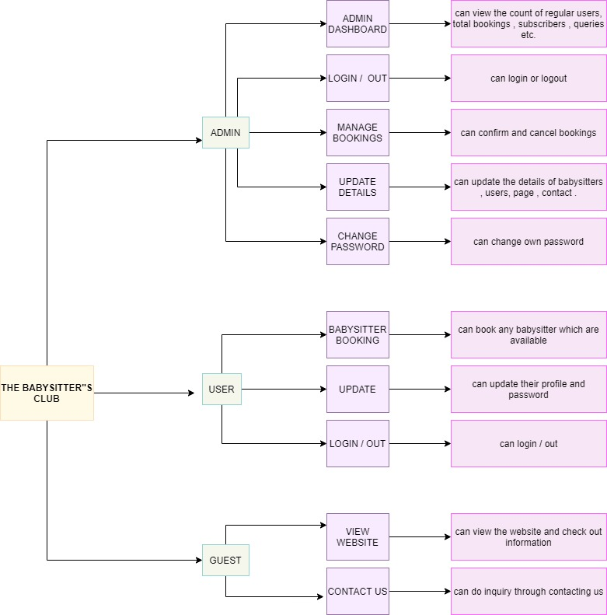

**DECISION TABLE: -**

**CONDITIONS**

|  |  |  |  |
| --- | --- | --- | --- |
| **Admin** | Yes | No | No |
| **User** | No | Yes | No |
| **Guest** | No | No | Yes |
| **Update** | Yes | Yes | No |
| **Login** | Yes | Yes | No |
| **Logout** | Yes | Yes | No |

**ACTIONS**

|  |  |  |  |
| --- | --- | --- | --- |
| **Register** |  |  | x |
| **Book a Babysitter** |  | x |  |
| **Update** | x |  |  |
| **See Booking History** | x | x |  |
| **Change Password** | x | x |  |
| **Manage Bookings** | x |  |  |

**3.2 Non-Functional Requirements:**

In systems engineering and requirements engineering, a non-functional requirement (NFR) is a requirement that specifies criteria that can be used to judge the operation of a system, rather than specific behaviours. Non-functional requirements are often called "quality attributes" of a system. It describes aspects of the system that are concerned with how the system provides the functional requirements.

Non-functional requirements are: -

* **Performance:** The sequential and hierarchical design of The Babysitter’s Club along with the latest versions of used technologies will provide new advances and boost performance.
* **Security**: The system should provide a high level of security and integrity of the data held by the system, only authorized user with valid password and username can login to view user’s page
* **Safety**: It is reliable because all the sensitive information will be transferred using post method and safe in PHP my admin and only admin can access this information.
* **Error Handling:** Error should be considerably minimized and an appropriate error message that guides the user to recover from an error should be provided. Validation of user’s input is highly essential.
* **Ease of Use:** Hierarchical design of our website makes simple to understand and easy to use for new users.

**3.3 Goals of implementation**

This software, called The Babysitter’s club will allow for the company to access their database securely and safely in a user-friendly online environment. Allowing for them to change information with ease. The software will be in sync with the both the Web App, allowing for real-time up-to-date services to their customers.

**PRACTICAL-02**

**TABLE OF CONTENTS**

**Data Flow Diagram (DFD)**

* 1. **DFD Level-0**…………………………………………………………………………………………**03**
  2. **DFD Level-1**…………………………………………………………………………………………**04**
* **DFD Level-0**

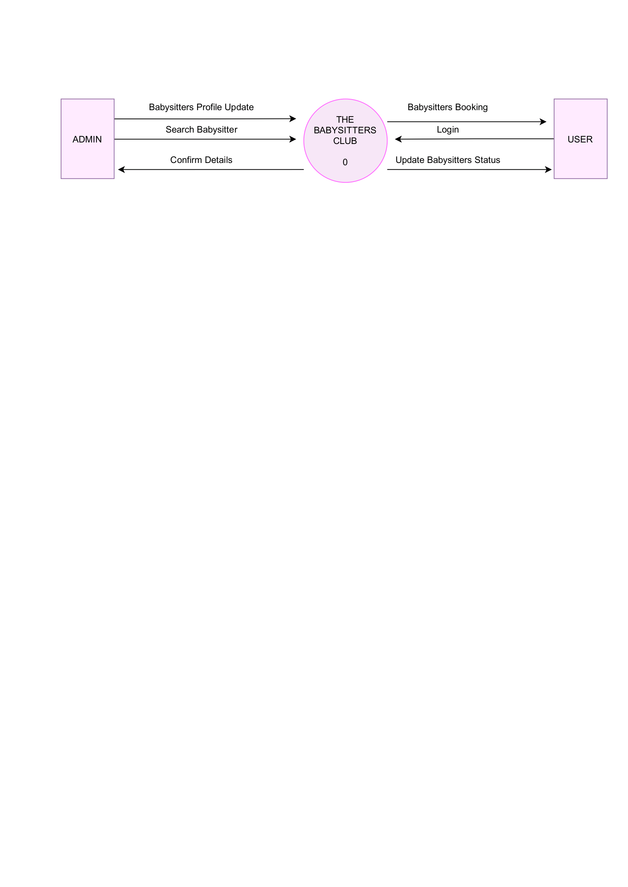

**Figure 1: DFD Level-0 of The Babysitters Club**

* **DFD Level-1**

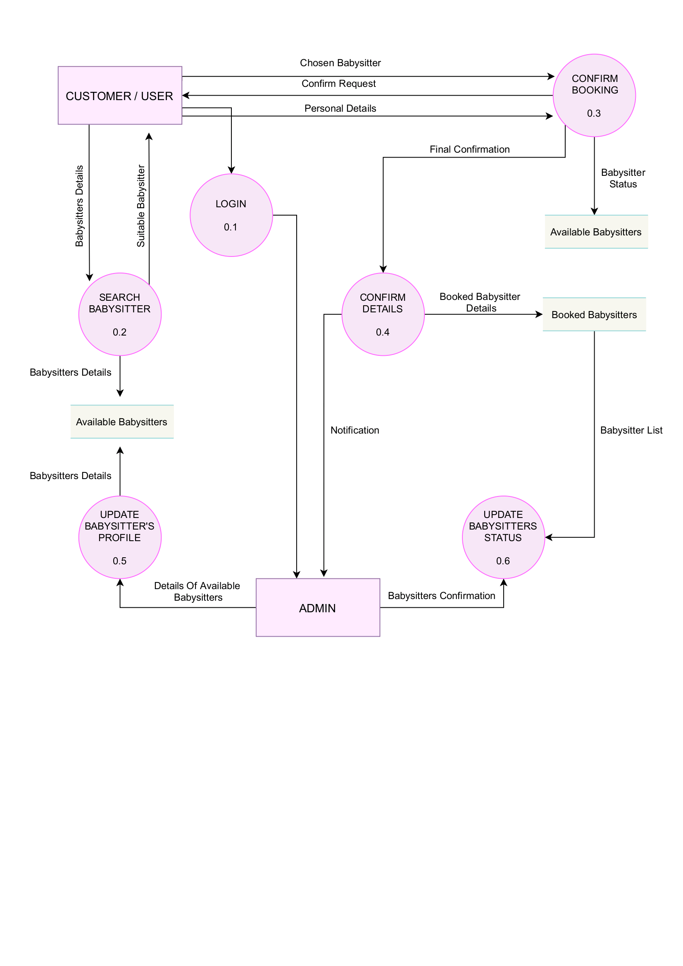

**Figure 2: DFD Level-1 of The Babysitters Club**

**PRACTICAL-03**

**Structure Chart (Transaction Centered Structure)**

**PRACTICAL-04**

**The UML Diagram (Unified Modeling Language Diagram)**

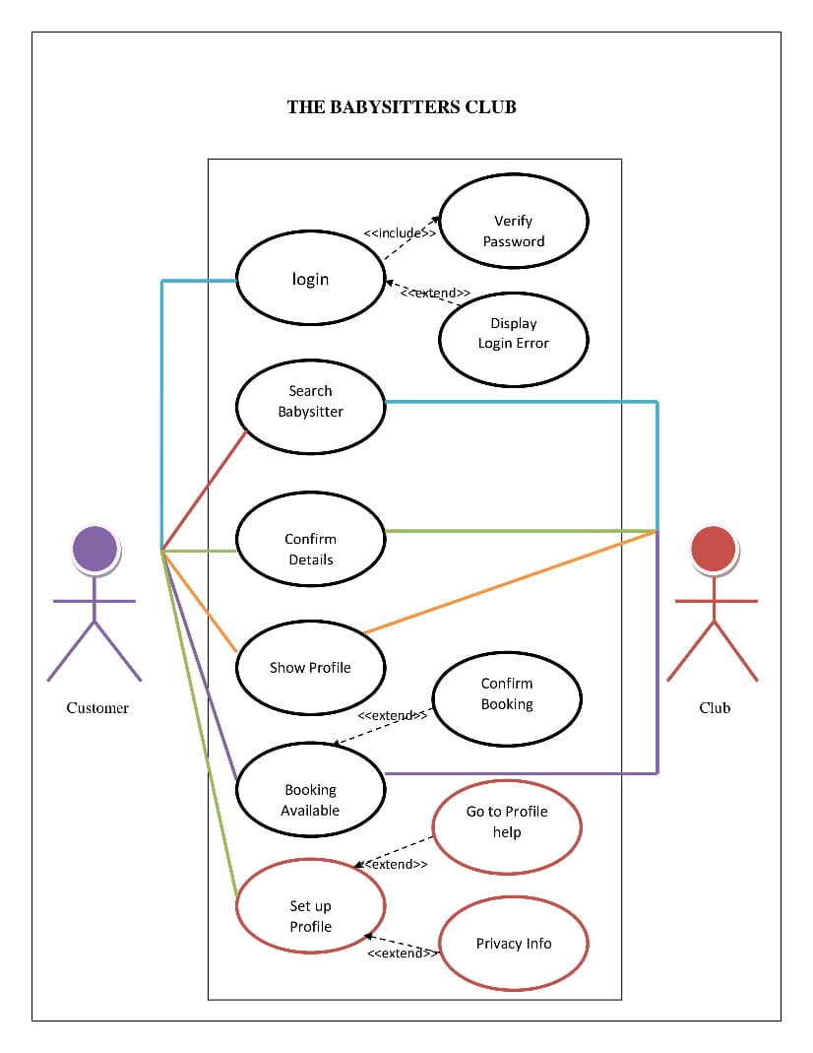

**PRACTICAL-05**

**Activity Diagram**

**PRACTICAL-06**

**The UML Class Diagram**

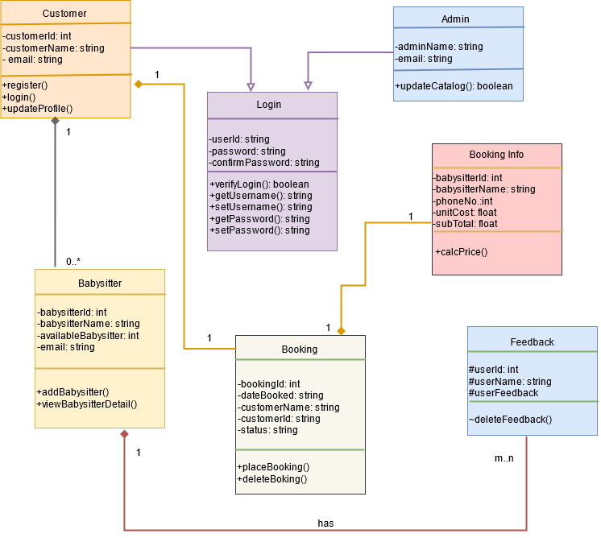

**PRACTICAL-07**

**Sequence Diagram**

